Types of mutations
There are a number of ways to classify gene mutations. Some classification schemes are based on the nature of the phenotypic effect, others are based on the causative agent of the mutation, and still others focus on the molecular nature of the defect.

Somatic versus germinal mutations
In multicellular organisms, genes can mutate in either somatic or germinal tissue and the changes are called somatic mutations and germinal mutations respectively. A germinal mutation arises in the germ line, a specific tissue that is set aside during development to form gametes. If a mutant gamete participates in fertilization then the mutation will be passed on to the next generation.
Hereditary versus acquired mutations
Gene mutations occur in two different ways: they can be inherited from a parent or acquired during a person’s lifetime. Mutations that are passed from parent to offsprings are called hereditary mutations. This type of mutation is present throughout a person’s life in virtually every cell in the body.
Mutations that occur in the DNA of the cell at some time during a person’s life are termed acquired mutations. These changes can be caused by environmental factors such as ultraviolet radiations or can occur if a mistake is made as DNA copies itself during cell division. Acquired mutations in somatic cells (cells other than sperm and egg cells) cannot be passed on to the next generation.
Types of mutation on the basis of molecular nature of mutation
The simplest type of gene mutation is a base substitution, the alteration of a single nucleotide in the DNA. Base substitutions are of two types. In a transition, a purine is replaced by a different purine or, alternatively, a pyrimidine is replaced by a different pyrimidine. In a transversion, a purine is replaced by a pyrimidine or a pyrimidine is replaced by a purine. Base substitution can cause missense, nonsense and silent mutations.
- A base substitution that alters the codon so that it specifies a different amino acid in the protein is referred to as a missense mutation.
- A mutation that changes a codon in a gene to one of the three termination codons (UAA, UGA or UAG) is described as nonsense mutation. If a nonsense mutation occurs early in the mRNA sequence, the protein will be greatly shortened and will usually be nonfunctional.
- Mutations without apparent effect are called silent mutations. A silent mutation changes a codon to a synonymous codon that specifies the same amino acid, altering the DNA sequence without changing the amino acid sequence of the protein.
- A neutral mutation is a missense mutation that alters the amino acid sequence of the protein but does not change its function. Neutral mutations occur when one amino acid is replaced by another that is chemically similar (For example, AAA AGA: changing basic lysine to basic arginine) or when the affected amino acid has little influence on protein function.

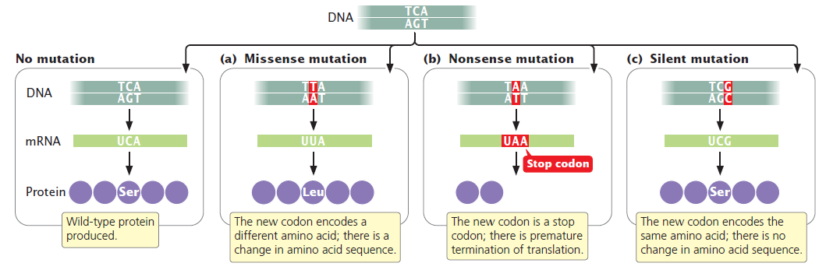
Functional Mutants
- Loss-of-function mutations cause the complete or partial absence of normal protein function. A loss-of-function mutation so alters the structure of the protein that the protein no longer works correctly or the mutation can occur in regulatory regions that affect the transcription, translation, or splicing of the protein. Loss-of-function mutations are frequently recessive, and an individual diploid organism must be homozygous for a loss-of-function mutation before the effects of the loss of the functional protein can be exhibited. The mutations that cause cystic fibrosis are loss-of-function mutations: these mutations produce a nonfunctional form of the cystic fibrosis transmembrane conductance regulator protein, which normally regulates the movement of chloride ions into and out of the cell.

- In contrast, a gain-of-function mutation produces an entirely new trait or it causes a trait to appear in an inappropriate tissue or at an inappropriate time in development. For example, a mutation in a gene that encodes a receptor for a growth factor might cause the mutated receptor to stimulate growth all the time, even in the absence of the growth factor. Gain-of-function mutations are frequently dominant in their expression.

- Still other types of mutations are conditional mutations, which are expressed only under certain conditions. A conditional mutant allele expresses a mutant phenotype only in a certain environmental condition called restrictive condition but produces a wild type phenotype in some different environmental condition, called the permissive condition. For example, some conditional mutants are called temperature sensitive mutants which give wild type phenotype at lower temperature (the permissive temperature), but exhibit mutant phenotype at high temperature (the restrictive temperature).

